CALL FOR COMPETITION PROPOSAL

The IFAC World Congress 2023 Organizing Committee invites proposals for competitions to be held during IFAC WC 2023 in Yokohama, Japan, in July 2023. The competitions provide a unique venue for state-of-the-art technical demonstrations from research labs, academia, and industry. Conference attendees and media representatives will have the opportunity to experience live demonstrations of robotic technology via these competitions.

Proposals must include the following information:
1. Title of the competition
2. A brief description of the competition, including what particular task(s), are under evaluation and why the competition is of interest to the IFAC community
3. A draft of the rules and scoring system
4. Title and type of prices or grants
5. Time schedule for competition day(s)
6. A list of possible/potential participants
7. Awards planning, including any financial plans
8. Request for the Organizing Committee for facilities, including
a) required space (area in square meters and minimum height),
b) energy, telecommunications network,
c) human resources needed,
d) any specific infrastructure you may need to do the competition.
9. Expected cost to hold the competition, and planning of funds/financial sponsors
10. Competition organizers’ names, contact information, and brief CVs of the competition organizers describing previous experiences in organizing competitions, workshops, etc.

IFAC WC 2023 organizing committee will ask the organizers to submit a list of participants before the congress takes place. The venue space is limited. IFAC WC 2023 may consult the available area for each competition at the acceptance decision stage.

If the competition organizer covers most of the necessary expenses for the proposed competition, the sponsorship benefits will be discussed individually. Please let us know when submitting the proposal.

How to submit and Contact information

All submissions will undergo a standard review process within the Competition Committee. Acceptance decisions will be based upon the potential significance, sustainability in IFAC, and logistical requirements. All the submissions should be made via email to competition@ifac2023.org with the subject: “Competition Proposal from (your name and surname)”

On-site Competition Details

Competition period: July 9 – 14, 2023. (Set-up begins on July 9)
Location: PACIFICO Yokohama Hall A
The venue space is limited. IFAC WC 2023 may consult the available area for each competition at the acceptance decision stage. Accepted competition venues would be relocated to optimize the space for all the activities in Hall A.

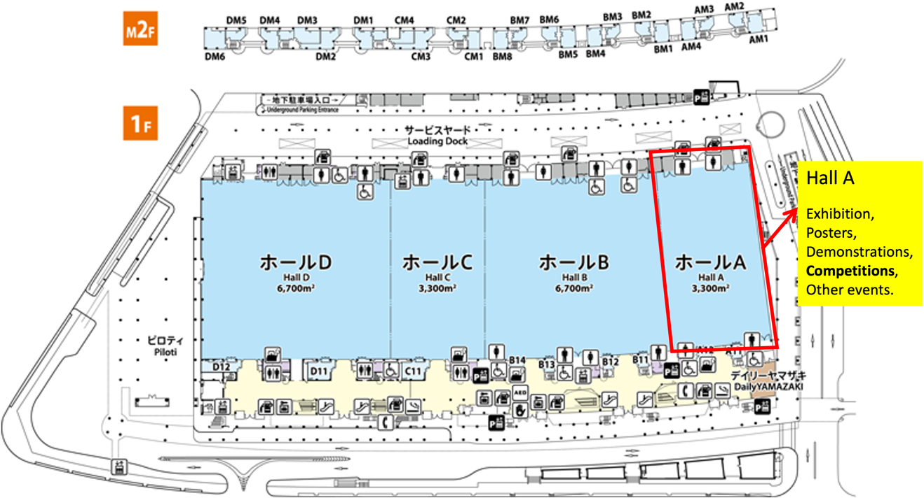

Important Dates

Submission deadline: November 15, 2022
Notification of acceptance: November 30, 2022

APPLICATION FORM
- Please read this application form carefully, and complete, and return the form to competition@ifac2023.org

General Information

Company Name _______________________________________________________________

Contact Person _______________________________

E-mail _______________________________

Tel Fax ___________ _________

Mailing Address _________________________________________________________________

City ____ Country _____________________Postal Code _______________

Proposals must include the following information:
1. Title of the competition
2. A brief description of the competition, including what particular task(s), are under evaluation and why the competition is of interest to the IFAC community
3. A draft of the rules and scoring system
4. Title and type of prices or grants
5. Time schedule for competition day(s)
6. A list of possible/potential participants
7. Awards planning, including any financial plans
8. Request for the Organizing Committee for facilities, including
a) required space (area in square meters and minimum height),
b) energy, telecommunications network,
c) human resources needed,
d) any specific infrastructure you may need to do the competition.
9. Expected cost to hold the competition, and planning of funds/financial sponsors
10. Competition organizers’ names, contact information, and brief CVs of the competition organizers describing previous experiences in organizing competitions, workshops, etc.

